Health and Physical Education
Grade 3 Study Guide for Heart Unit

P.E. Standard: 10.1.3 B Identify and know the location and function of the major body organs and systems.

DIRECTIONS: Please review the following information with your child for our 12 point Health and Physical Education quiz.

ALL STUDENTS SHOULD UNDERSTAND.

- Two common forms of heart disease are heart attack and stroke.

- The heart and lungs work as a team to supply the body with fresh oxygen.

- The circulatory system pumps blood throughout the body.

- The lungs are part of the respiratory system which supplies the body with oxygen.

- You can find your pulse on your neck or wrist.

- A stroke occurs in the brain.

- Inactivity, diet high in fat, obesity and smoking are risk factors of heart disease.

- A risk means you are more likely to have heart disease.

- 60 minutes of regular exercise and a healthy nutritious diet can help prevent the risk factors of heart disease.

- Aerobic exercise works the heart and lungs to make them stronger and more efficient.

- The heart muscle has 4 chambers.

- Arteries carry oxygen rich blood to the muscles.
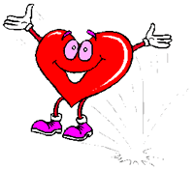
- Veins carry oxygen poor blood.

- In an emergency call 911

